

**INTERNAL MEETING MINUTES**

|  |  |
| --- | --- |
| Meeting Purpose | TDWG RASD Group Meeting |
| Time and Date | 24th September 2025, from 21:00 AEST |
| Attendees | Piers Higgs  Mieke Strong  Cam Slatyer  Tania Laity  William K Morris  Cecilie Skraep Svenningsen  Andrew Rodrigues  Alice Hughes  Rebecca Boyland |

**Agenda**

* Finalisation of the Vocabs
* Mieke presenting on Darwin Core Data Package and Data Modelling exercise (to implement the DWC Extension)

**Minutes**

Welcome to the meeting from Cam, and a welcome to country from a cold and frozen Canberra.

Swapping the presentation and then we’ll have a discussion about where to establish sub-groups - next implementation stages of adapting the model into DwC DP but also a second one to look at “demodify” what we’ve worked on to match the DwC standard.

[Mieke’s presentation](https://github.com/tdwg/sensitive-species-extension/blob/main/RASD%2020250924.pptx)

We are aiming towards adjusting the vocabulary structure that the group has come up with so that it can be used in more FAIR way and to apply this conceptual model to DWC Data Package and DWC Native implementations of the extension.

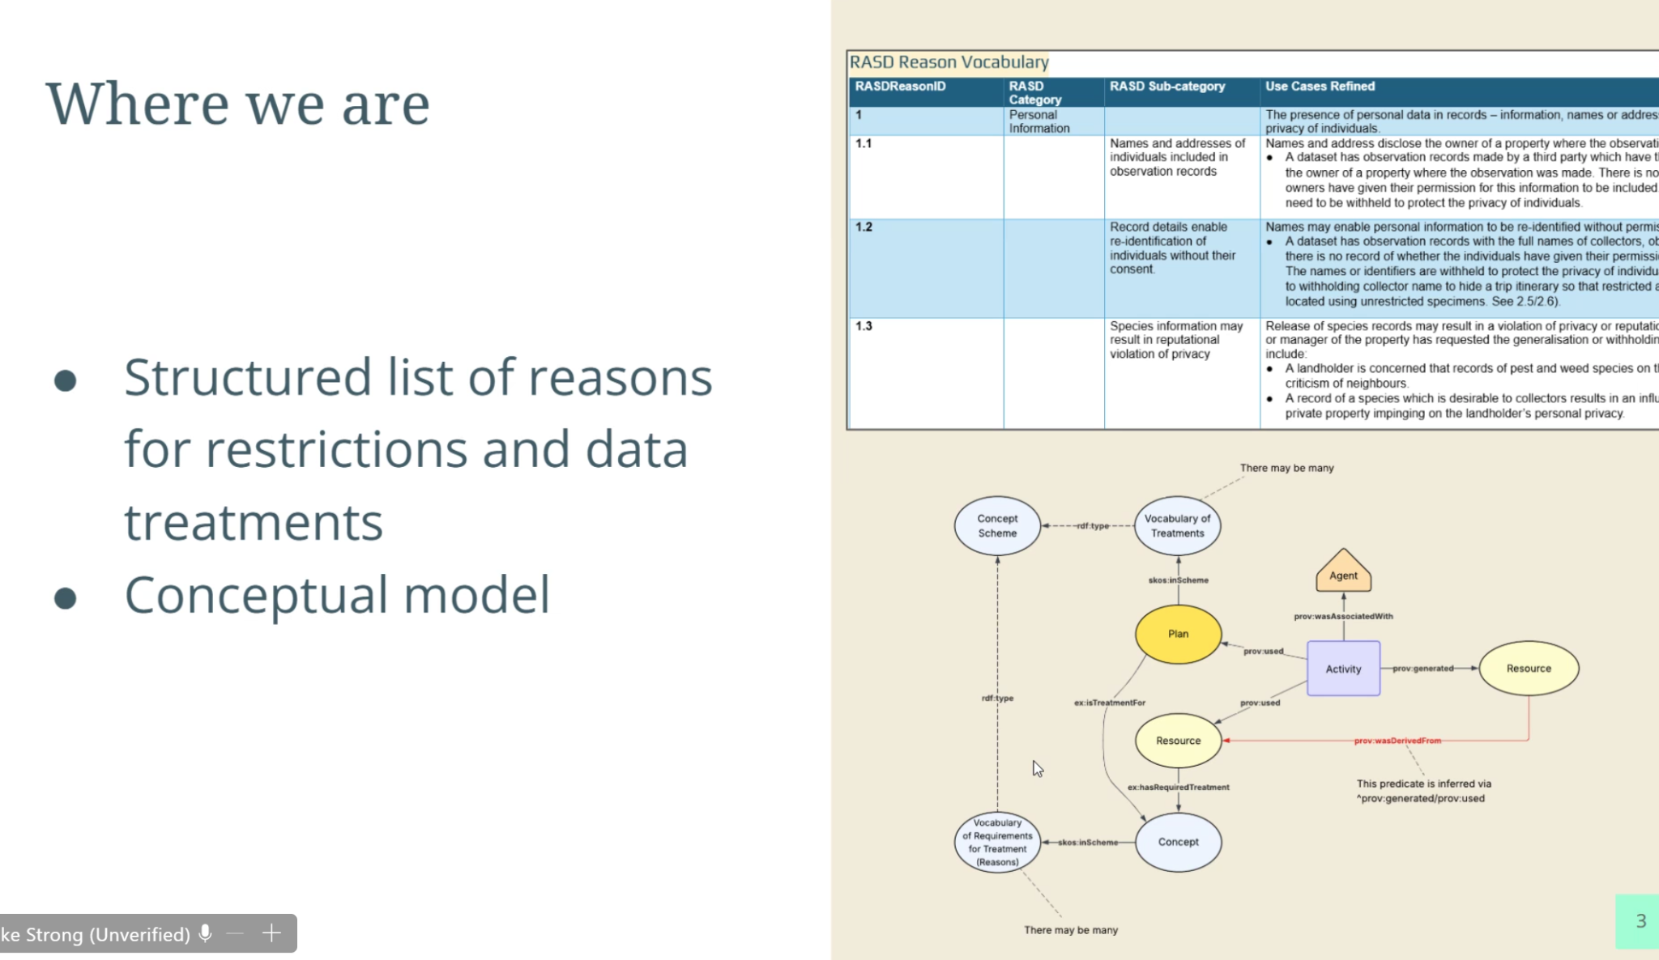

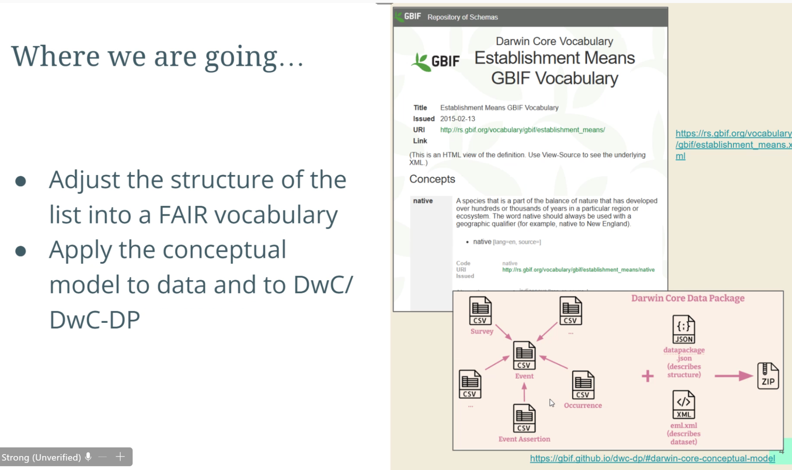

Mieke has been working on taking the table and creating a structure that is web-based, accessible and link terms together in an hierarchical way. Moved away from numbering system – created short phrase name instead (still references the numbering system in the table but that will have to be replaced when implemented. Mieke has already coded it up and it’s essentially ready to be implemented i.e. could have something similar to the [DWC Establishment Means Vocabulary](https://rs.gbif.org/vocabulary/dwc/establishment_means_2025-07-10.xml).

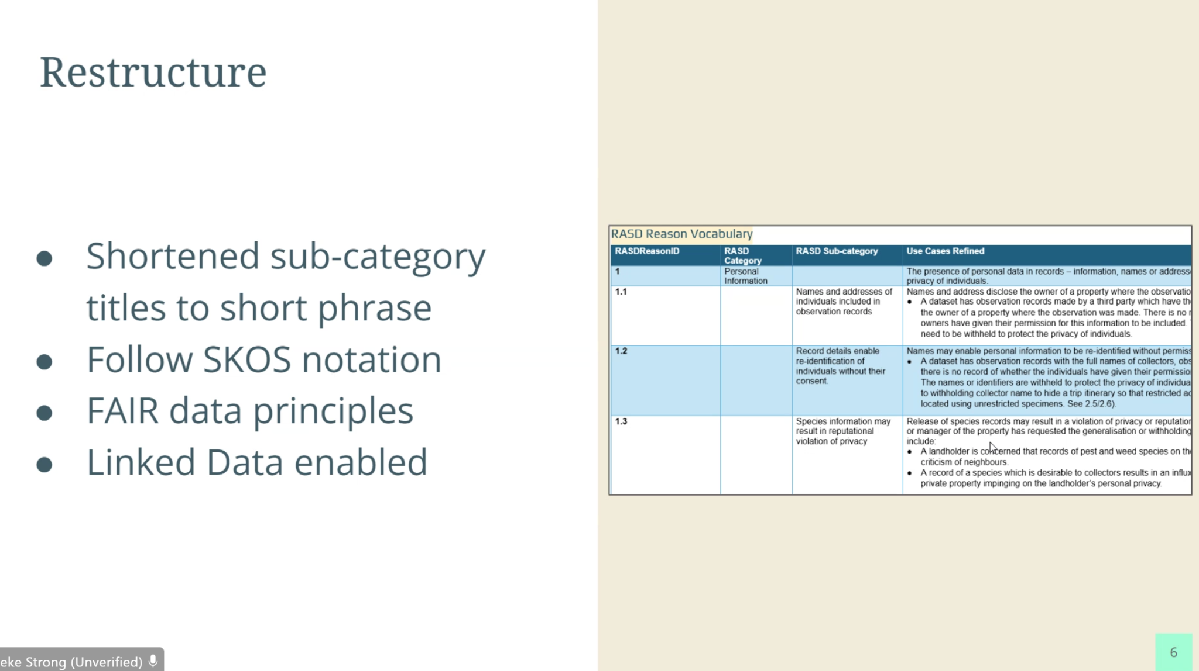

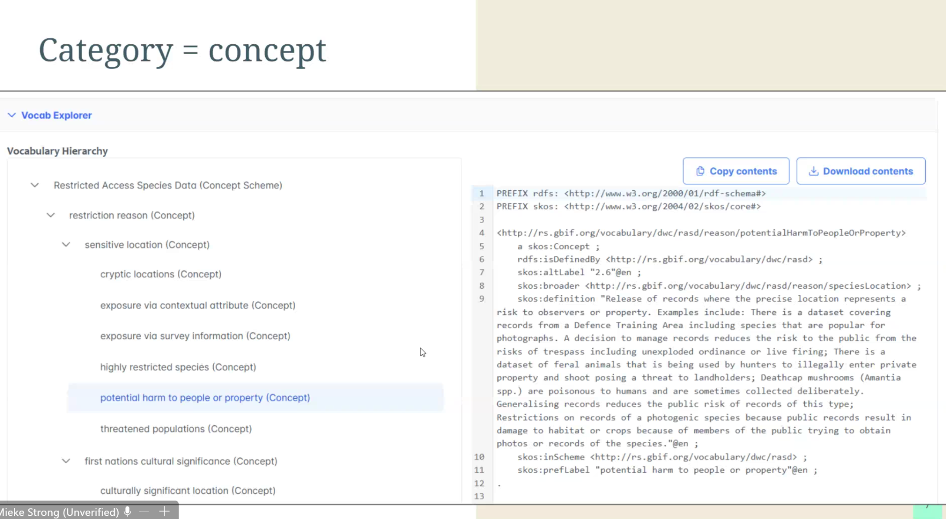

Mieke wanted feedback from the group on the shortened names for the vocabulary terms? Asked if the group wanted her to share the draft before she adds the invalid usage examples - general agreement from group.

Cecilie - question: like establishment means - can be mapped to a specific record in GBIF - is that the same you envision here in these concepts? Leading into this part of the presentation.

High level concept is as below to give an overview of the process. This shows that the original resource is still available and a second generalised resource that has had treatments applied.

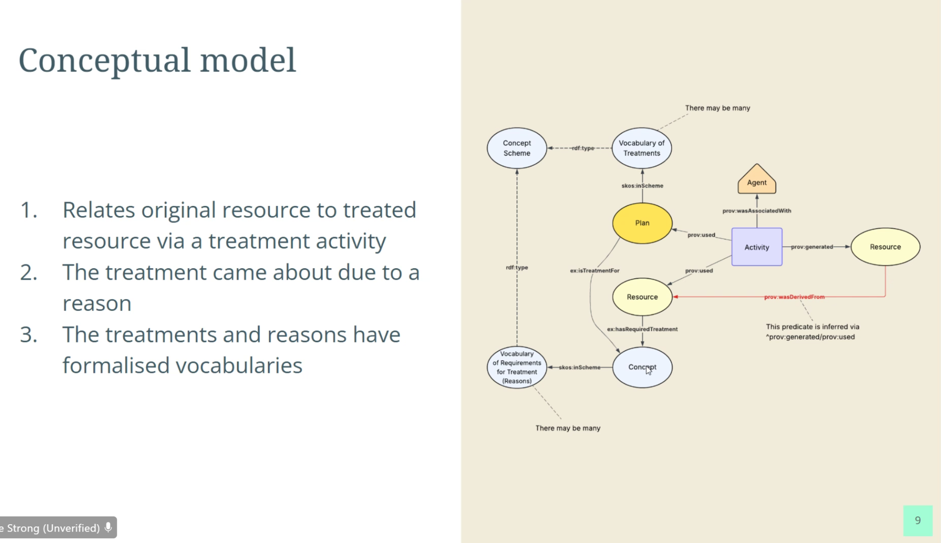

The treatment is the core thing we want to know about as it is what is applied to the data. The diagram below shows all the other additional information we need to include e.g. date, duration, agent, type etc. Included as both a diagram and a tabular view. Asterixis are the suggested mandatory fields. Fields in bold in the table are where we have vocabularies.

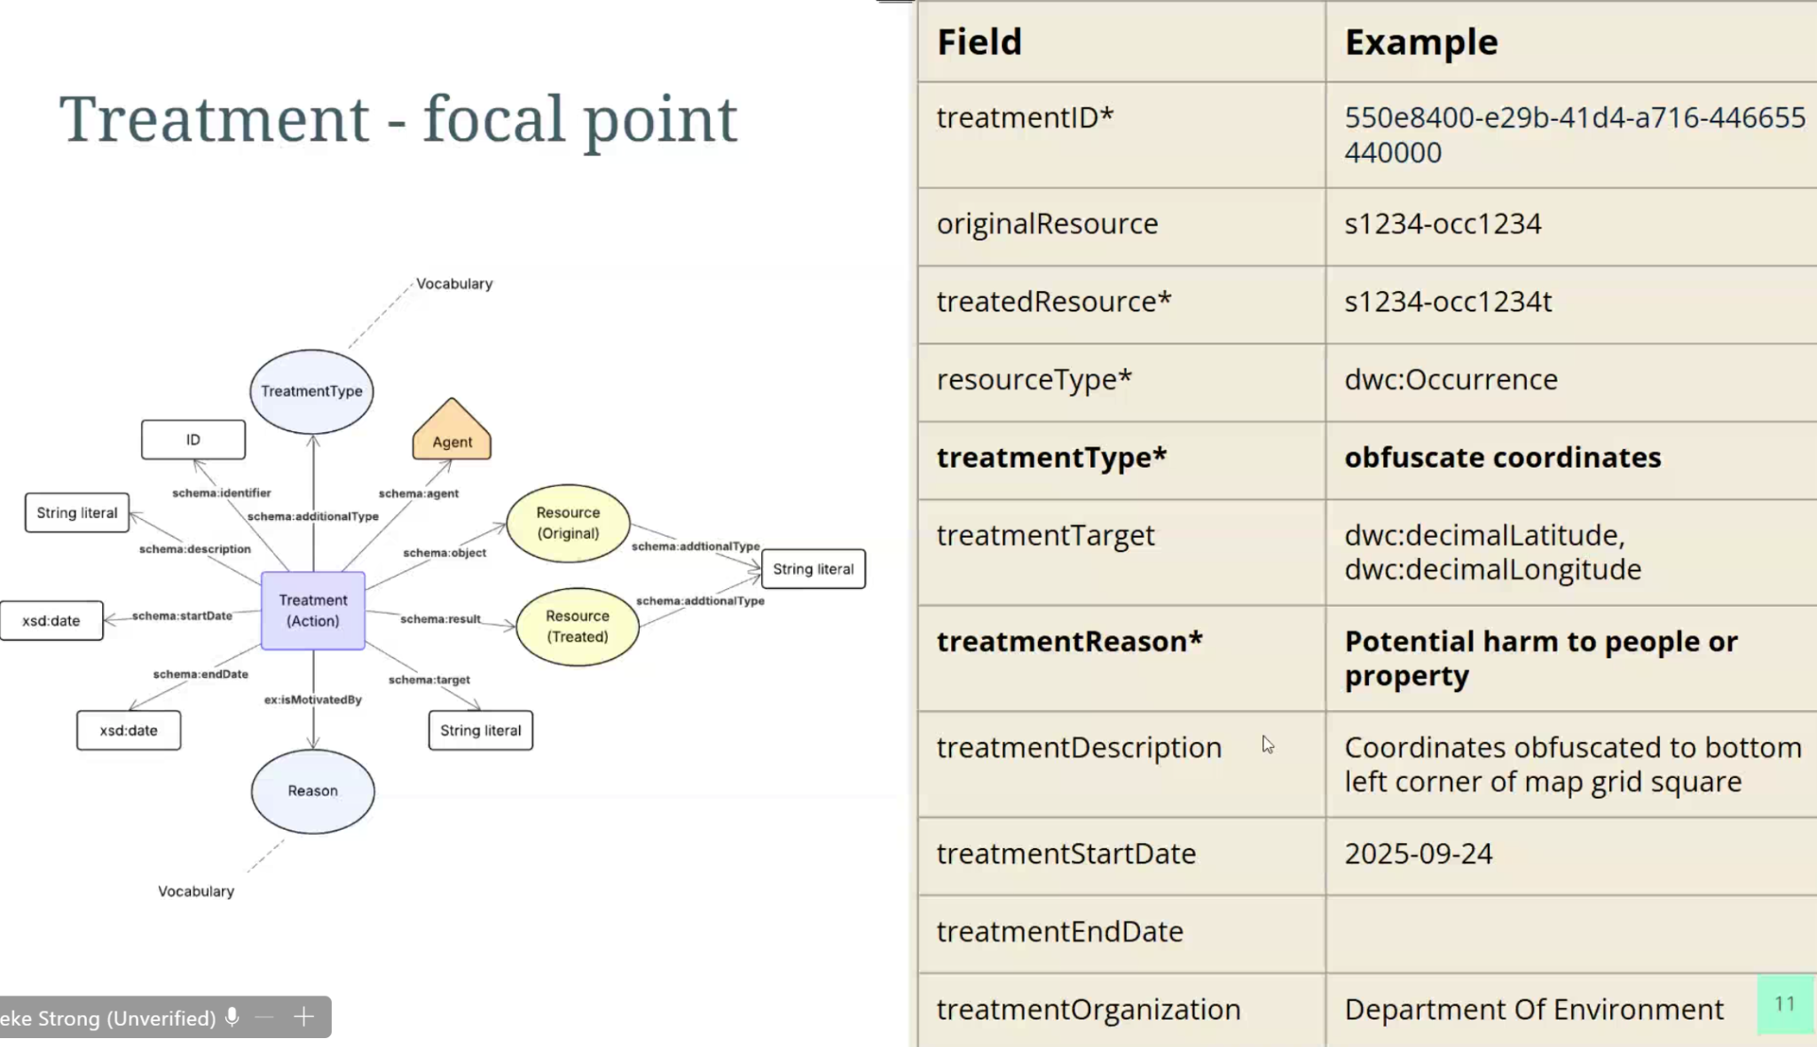

In the DwC Data Package overall conceptual model, it’s assumed that treatments fit within the group of entities that have many to many relationships at various points within the core model as there may be sensitive information that needs to be treated in for example, survey, occurrence, event etc.

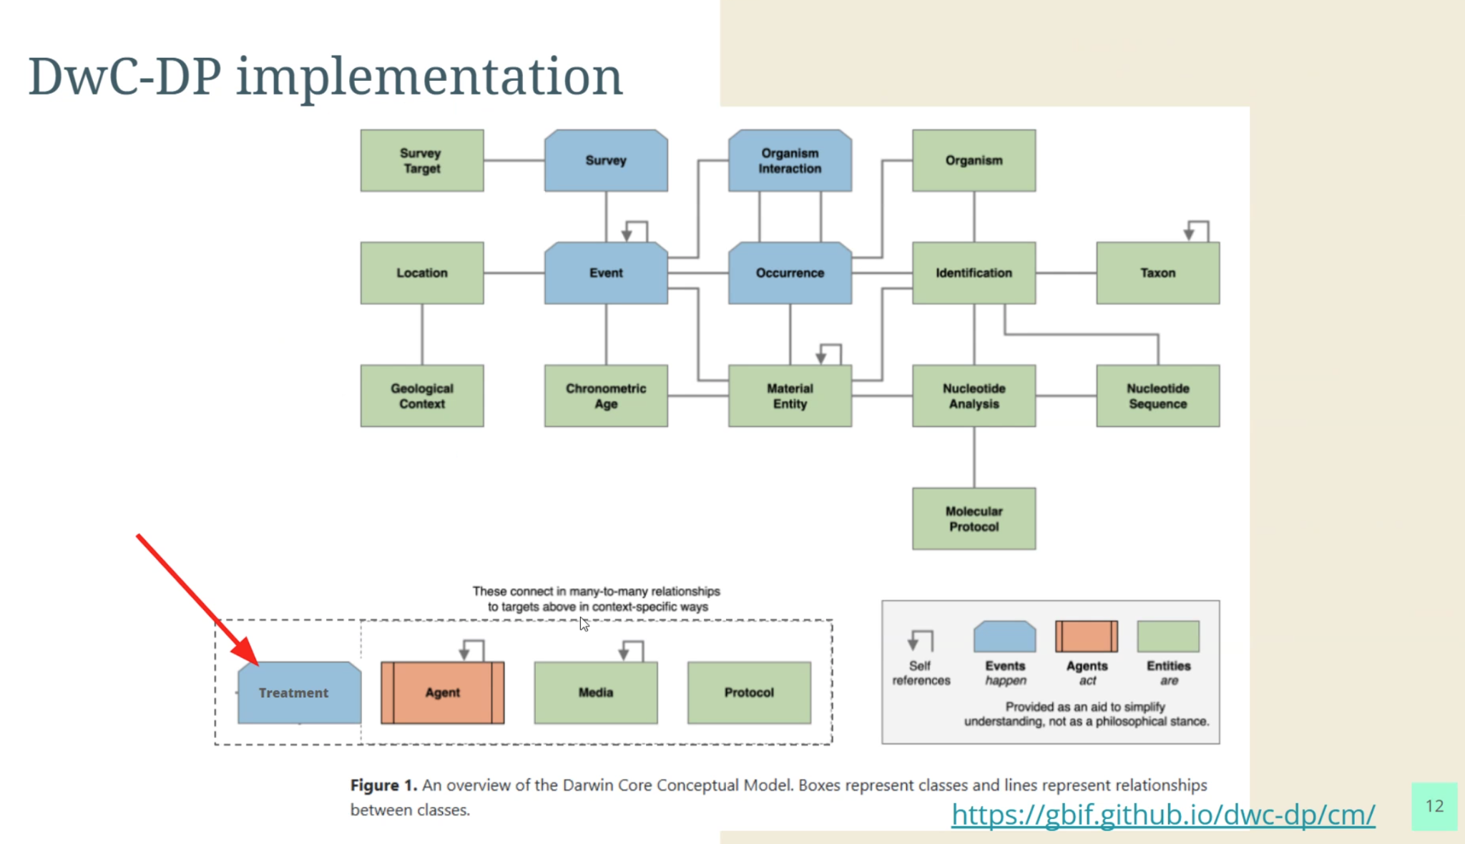

But in a plain DwC implementation – could potentially do it as JSON Key Value Pairs (KVPs) in a similar manner to the DynamicProperties:

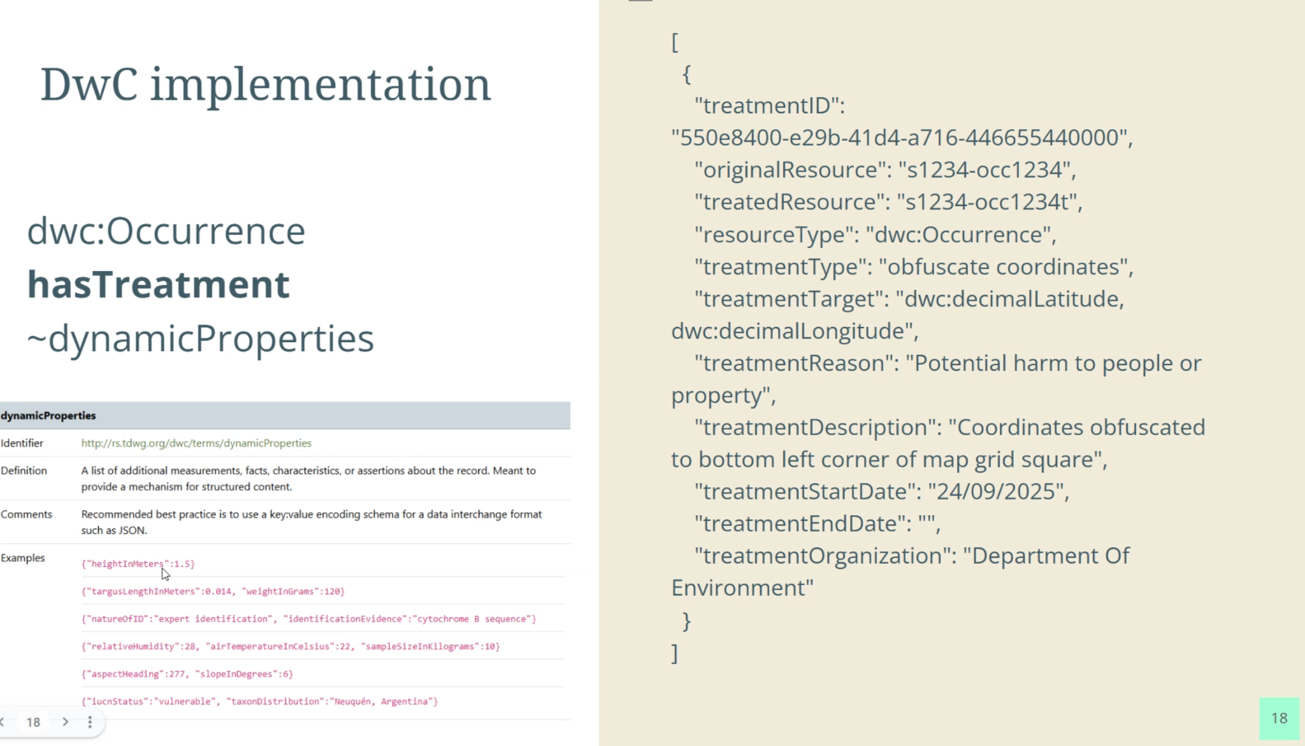

Cam - is there enough flexibility to do what we are talking about in dynamicproperties?

Mieke – not suggesting that we use dynamicProperties rather a new field for treatments that is implemented in a similar way to dynamicproperties.

Cecilie - did you explore assertions for capturing this as well - all these tables have assertions and most of these could apply?

Mieke - Yes, but assertions are named based on the thing they are relating to, and also they didn’t have quite as many fields e.g. end dates; (Cecilie - would have to have individual types for each - assertiontype:startdate, assertiontype:enddate, like you are doing here in the slide (above).) Having the treatments as its own table might be able to know about any restrictions on any part of the data - instead of trying to find it - you could find it all in one place, rather than go looking for it in a separate part of the data model.

Cecilie - would provide recommendations on the string, right?

Mieke - Yes. More instruction would be required - like the standard DwC fields, etc.

From Cecilie on chat:  
*The original idea for Assertions in DwC-DP is to parse out dynamicProperties, so it seems like a regression on that. However, I am not in the know of all your work behind this suggestion for a dynamicProperties-like term. It seems it is more challenging to update for publishers than keeping it as separate assertion types*

*For DwC-DP, there's also the option for resource relationship mapping, that may make sense for keeping track of different IDs for the same resource behind the treatments:* [*https://gbif.github.io/dwc-dp/qrg/#Resource%20Relationship*](https://gbif.github.io/dwc-dp/qrg/#Resource%20Relationship)

Piers - can we do multiple treatments on a particular record I can do this in the json blob - with a stacked curly brackets – yes – you can.

Rebecca (new to BIO, Filling in for Cassia) - is able to capture things like cockatoo nest trees, and protect those records as well as the species records.

From Alice in chat:  
*for example if I was modelling nesting areas of species and some of the records had had their coordinates changed due to their publishers treatment- I need to remove them because they would screw analysis*

Mieke - Yes - quite a vocabulary around it like nesting sites and all that can pick up and then make this record sensitive.

Will - wondering about the idea of a different identifier for the original and treated resource - is that a good idea? Given that once you treat it is still the same resource, you’re just not sharing all the information. So how different is it if I publish records, find a mistake and fix the mistake, I don’t change the identifiers, so people know it’s the same on. Would that be the same thing if I was applying treatments?

Mieke - Good point - not a data publisher so not entirely sure if we would keep the same or not - some people have two versions, do we have the same identifier, versioning history, might be up to the data custodian as to how they do that versioning - but if there is never going to be a separate identifier maybe we don’t need both resources captured in the data table and just have the one.

Will: Dunno; just thinking it through

Alice: Would need a flagged and an unflagged version (e.g. with a “f” for filtered - rather than seeing that there are two entries you can tell them apart - most likely to change the taxonomic resolution or coordinates - so if filtering the duplicates so you would want to make sure that the ones with an “F” are filtered – we know that much of this data is uploaded in lots of different forms. So knowing it was originally flagged or raw data, so might end up with two versions that look like the same thing with different identifiers.

Will: Yes, but don’t want meaning ascribed to identifiers that’s not best practice. You want this model sharing the treatment information it with the data shows that a records has been treated.

Mieke: depends when you use this and when you apply this - there might be different versions out there in systems e.g. public vs restricted data. So keeping track of what has happened to records might be important - working out which is which is handy for management, but not just the publication side. But if you’re just going to GBIF, ALA, whatever and then looking at a published record, what it was called originally may not matter - but when you are using it in your own it might be useful. But open to other ways to make it work as well - do we need a “flagged” field instead and what does that look like?

Will – for me the motivation is for the sharing of data via standards.

Mieke – You want to manage your data internally so you are ready to share?

Cam – Agree with Will - Fiddling with the ID is a high risk strategy – we have enough duplication as it is – favour the idea of a flag field, otherwise it’ll get lost in the noise at the aggregation level. Keep the original ID.

Mieke – get rid of the second field – an add a flag field.

Will – you’d have a table of treatment vs occurrence ids etc

Andrew – what is a flag – is it a flag within GBIF or a flag in the standard?

Will – Treatment is the flag basically. Not sure if they’re necessary - the fact there is a treatment related to an occurrence or something would make sense.

Andrew: when you talk about flags - are you talking about a flag in GBIF or a flag in the standard here.

Cecilie: a flag in GBIF is something done at the processing step so if there was data with treatments could add a flag in GBIF as well. If it’s consistent. Still think assertions are valuable - But that’s why DwC data packages are useful.

Mieke offered to share the analysis of the assertions later if that’s useful.

In the vocabularies themselves we reference treatments to records or datasets – the concept of dataset is not explained in such a way in DwC. Ie what are we talking about a record what do we actually mean? Need to define?

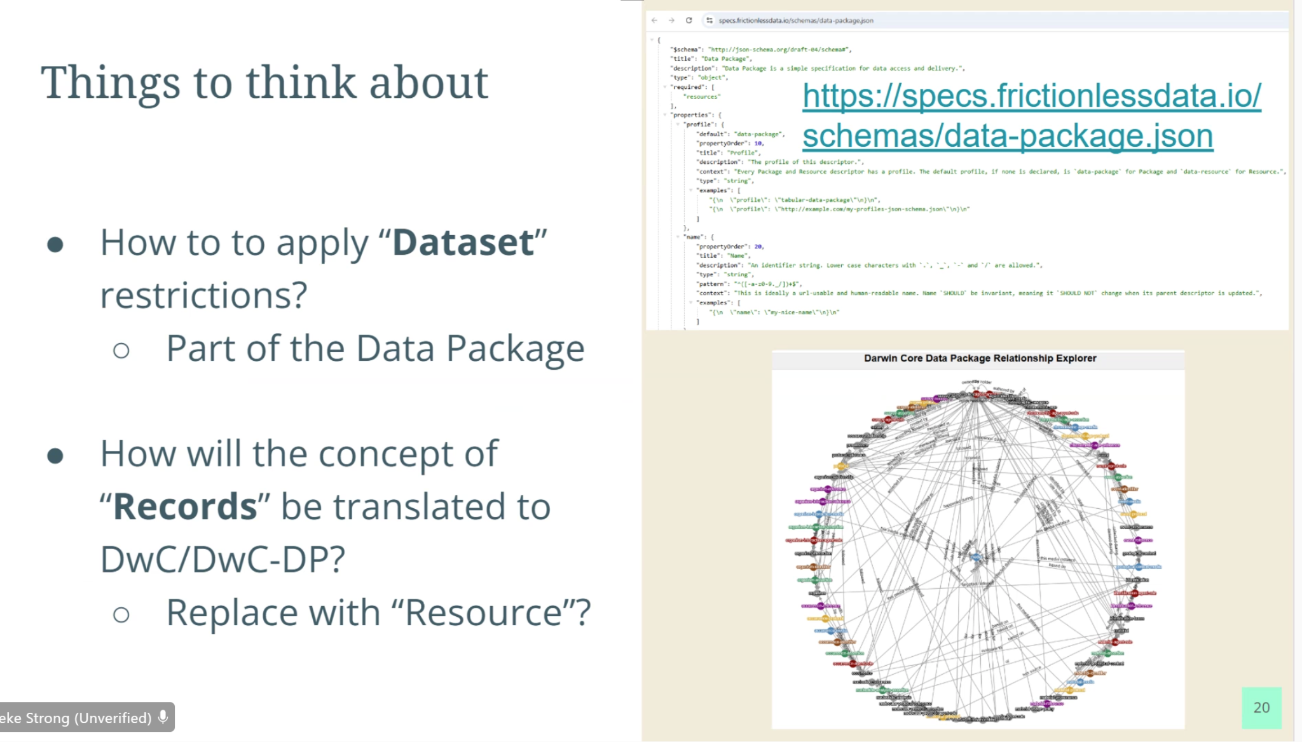

Should we consider replacing “records” with the term “resource” because anything could be “sensitive”...

From Cecilie:  
*One thing to keep in mind that there will be a DwC-DP profile that does introduce some restrictions on what you include in the DP. Otherwise data aggregators will not be able to incorporate the 'wild-west' of different structures of data packages*

Will: In the previous model we referenced things like “target” so maybe we should lean into those properties - we’re actually treating properties of classes rather than resources e.g latitude AND longitude. Maybe we should be leaning into that atomisation – we are actually treating properties of DWC classes..

Mieke: What does a “record” mean…. But you wouldn’t want to list it out for each property as that would take ages to do. Will: true

Cam: agree with that - if you want to remove an entire record/observation is resource a common enough analogue for those things? And you will get no ambiguity?

Mieke: In DWC there’s a thing called resourcerelationship - in that field we have resources as occurrences/events and other things so it’s spelled out what is a resource - so shouldn’t be super groundbreaking to call it a “resource” - should be well understood there.

Cam: need to think about it

Will: how in practice would we deal with this if an entire resource is withheld how would you refer to it then - with its identifier? In which case parts aren’t withheld?

Cam: You might have a record/resource etc with an identifier with all other fields empty apart from the fields that say it’s withheld.

Will - So that goes back to the point - if to only refer to it is through the identifier, so you haven’t withheld it, you’ve just applied the treatment with its properties.

Mieke – if you have the treatment table in the DwC-DP you can refer to an identifier but it doesn’t have to be visible in the occurrence table because its been withheld.

Will: In current Dwc has to be in the occurrence file –

Mieke - you would have no properties, just an identifier, and then the treatment fields.

Cecile on chat: *Did you have a dataset use case you mapped to DwC-DP? It might be very helpful with a practical exercise*

Cam: great presentation, Mieke, sets foundation for the next steps.

We need to set up 2 sub groups to discuss these issues wrt DwC and DwC- DP

**Action WG Members - people nominate to be included into either sub-group - DwC DP and DwC – members to indicate by email by end of the week if you’re prepared to join a sub-group dealing with DwC or DwC DP implementation - and then look at wider group to actually discuss and test these issues.**

Meeting Closed: 21:56 AEST